**ASSIGNMENT 1 FRONT SHEET**

|  |  |  |  |
| --- | --- | --- | --- |
| **Qualification** | **TEC Level 5 HND Diploma in Computing** | | |
| **Unit number and title** | **Unit 43: Internet of Things** | | |
| **Submission date** | 27/11/2022 | **Date Received 1st submission** |  |
| **Re-submission Date** | 22/12/2022 | **Date Received 2nd submission** |  |
| **Student Name** | Do Huu Duy | **Student ID** | GCC200018 |
| **Class** | GCC0903 | **Assessor name** | Luong Hoang Huong |
| **Student declaration**  I certify that the assignment submission is entirely my own work and I fully understand the consequences of plagiarism. I understand that making a false declaration is a form of malpractice. | | | |
|  |  | **Student’s signature** | huuduy |

**Grading grid**

|  |  |  |  |  |  |  |  |  |  |
| --- | --- | --- | --- | --- | --- | --- | --- | --- | --- |
| P1 | P2 | P3 | P4 | M1 | M2 | M3 | M4 | D1 | D2 |
|  |  |  |  |  |  |  |  |  |  |

|  |  |  |
| --- | --- | --- |
| **❒ Summative Feedback: ❒ Resubmission Feedback:** | | |
| **Grade:** | **Assessor Signature:** | **Date:** |
| **Internal Verifier’s Comments:** | | |
| **Signature & Date:** | | |

# Assignment Brief 1 (RQF)

## Higher National Certificate/Diploma in Business

|  |  |
| --- | --- |
| **Student Name/ID Number:** |  |
| **Unit Number and Title:** | **Unit 43 – Internet of Things** |
| **Academic Year:** | **2021** |
| **Unit Assessor:** | **Tran Trong Minh** |
| **Assignment Title:** | **Assignment 1 – Internet of Things** |
| **Issue Date:** |  |
| **Submission Date:** |  |
| **Internal Verifier Name:** |  |
| **Date:** |  |

|  |
| --- |
| **Submission Format:** |
| *Format:* This assignment is an Individual assignment and specifically including 1 document:  You must use font *Calibri size 12, set number of the pages and use multiple line spacing at 1.3. Margins must be: left: 1.25 cm; right: 1 cm; top: 1 cm and bottom: 1 cm.* The reference follows Harvard referencing system. The recommended word limit is *2.000-2.500 words*. You will not be penalized for exceeding the total word limit. The cover page of the report has to be the Assignment front sheet 1.  *Submission* Students are compulsory to submit the assignment in due date and in a way requested by the Tutors. The form of submission will be a soft copy posted on <http://cms.greenwich.edu.vn/>  *Note:* The Assignment *must* be your own work, and not copied by or from another student or from  books etc. If you use ideas, quotes or data (such as diagrams) from books, journals or other sources, you must reference your sources, using the Harvard style. Make sure that you know how to reference properly, and that understand the guidelines on plagiarism. *If you do not, you definitely get fail* |
| **Unit Learning Outcomes:** |
| **LO1** Analyze what aspects of IoT are necessary and appropriate when designing software applications  **LO2** Outline a plan for an appropriate IoT application using common architecture, frameworks, tools, hardware and APIs  **LO3** Develop an IoT application using any combination of hardware, software, data, platforms and services.  **LO4** Evaluate your IoT application and detail the problem your IoT application solves, the potential impact on people, business, society and the end user and the problems it might encounter when integrating into the wider IoT ecosystem |
| **Assignment Brief and Guidance:** |
| You currently work as a product developer for a new startup where you design IoT products for the consumer, corporate, government and defence clients. As part of your role your manager has tasked you to plan and develop a new IoT product, service or application for a potential client. You are required to identify a target user and conduct tests with this user and include this feedback into multiple iterative versions of your product.  **Part 1 (Assignment 1)**: For the first part, you must:   * Plan an IoT application for a specific target end user and the tests you intend to conduct with this user. This plan will be in the form of a document and will include supporting evidence and material, such as user personas and customer journey maps. * Create multiple iterations of your application and modify each iteration with enhancements gathered from user feedback and experimentation. This will follow the pathway outlined in your plan (log book,)   **Part 2 (Assignment 2)**: For the first part, you must:   * Show evidence about Developed IoT application using any combination of hardware, software, data, platforms and services (video or images of your IoT system with code snippet) * Evaluate your IoT application and detail the problem your IoT application solves, the potential impact on people, business, society and the end user and the problems it might encounter when integrating into the wider IoT ecosystem |

|  |  |  |
| --- | --- | --- |
| Learning Outcomes and Assessment Criteria | | |
| Pass | Merit | Distinction |
| **LO1** Analyse what aspects of IoT are necessary and appropriate when designing software applications | | |
| **P1** Explore various forms of IoT functionality.  **P2** Review standard architecture, frameworks, tools, hardware and APIs available for use in IoT development. | **M1** Evaluate the impact of common IoT architecture, frameworks, tools, hardware and APIs in the software development lifecycle.  **M2** Evaluate the impact of common IoT architecture, frameworks, tools, hardware and APIs in IoT security. | **D1** Evaluate specific forms of IoT architecture and justify their usage when designing software applications. |
| **LO2** Outline a plan for an appropriate IoT application using common architecture, frameworks, tools, hardware and APIs | | |
| **P3** Investigate architecture, frameworks, tools, hardware and API techniques available to develop IoT applications.  **P4** Determine a specific problem to solve using IoT. | **M3** Select the most appropriate IoT architecture, frameworks, tools, hardware and API techniques to include in an application to solve this problem.  **M4** Apply your selected techniques to create an IoT application development plan. | **D2** Make multiple iterations plan of your IoT application and modify each iteration to improve your IoT application security. |

Table of Contents

I. Explore various forms of IoT functionality 8

1. Definition about Internet of Things (IoT) 8

2. How does IoT work? 8

3. IoT features 9

4. Applications of IoT 11

5. Some examples for real world application of IoT 13

II. Review standard and investigate architecture, frameworks, tools, hardware and APIs available for use in IoT development 16

1. Architecture of IoT 16

3. Tools 19

4. Hardware 21

5. API 25

III. Determine a specific problem to solve using IoT 28

1. Problem 28

2. Solution 28

References 30

Table of Figures

Figure 1. Some application in IoT (meterial, 2022) 8

Figure 2. How does IoT work (meterial, 2022) 9

Figure 3. Features of IoT (meterial, 2022) 10

Figure 4. Application of IoT in Smart House (meterial, 2022) 11

Figure 5. Application of IoT in Wearables (meterial, 2022) 12

Figure 6. Application of IoT in Smart City (meterial, 2022) 12

Figure 7. Application of IoT in Smart Grid (meterial, 2022) 13

Figure 8. Real world application of IoT in Remote monitoring (azure.microsoft, 2022) 14

Figure 9. Real world application of IoT in Predictive maintenance (azure.microsoft, 2022) 15

Figure 10. Real world application of IoT in Facilities management (azure.microsoft, 2022) 16

Figure 11. Architecture layers of IoT (meterial, 2022) 17

Figure 12. Architecture of IoT (geeksforgeeks, 2022) 18

Figure 13. Framework of IoT (meterial, 2022) 18

Figure 14. Arduino Uno tool(avsystem, 2019) 19

Figure 15. Node-Red tool (avsystem, 2019) 20

Figure 16. Arduino Uno hardware (arduino, 2022) 23

Figure 17. PIR Motion Thermal Sensor HC-SR501 hardware (electrocrea, 2022) 24

Figure 18. Apply API to IoT (wallarm, 2022) 25

# I. Explore various forms of IoT functionality

## 1. Definition about Internet of Things (IoT)

The Internet of Things (IoT) describes the network of physical objects that are embedded with sensors, software, and other technologies for the purpose of connecting and exchanging data with other devices and systems over the internet. These devices range from ordinary household objects to sophisticated industrial tools. The term Internet of Things (IoT) mentions a collective network of all devices connected and technology to communication conditions between devices and cloud services. The Internet of Things integrates everyday “things” with the internet. Thanks to the advent of low-cost chips and high-bandwidth telecommunications, there are billions of devices is connected to internet. That means some daily devices such as vacuums, cars, and machines can use sensors to collect data and respond intelligently to users. To sum up, the Internet of Things (IoT) is about almost every area, device, sensor, software, etc. being connected to each other. The ability to access these devices through a smartphone or through a computer from a distance is called IoT (amazon, 2022)

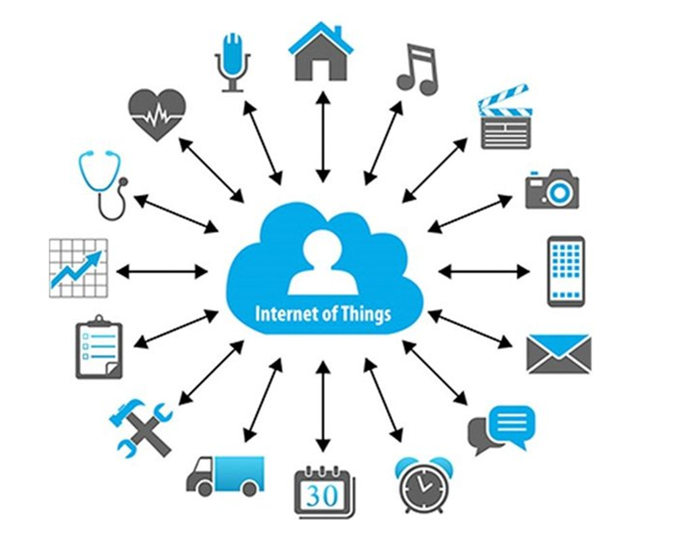

Figure 1. Some application in IoT (meterial, 2022)

## 2. How does IoT work?

An IoT system operates through data collection and exchange in real-time. The IoT system has three ingredients. that is smart devices, IoT applications, and a graphical user interface (amazon, 2022)

**Smart devices:** That is some devices such as televison, security cameras, and exercise devices are supplied with the calculation ability, they collect the data from the environment, user input or usage patterns, and data transmission over the internet to and from its IoT application.

**IoT applications:** These are the collection of devices and applications that integrate data received from different IoT devices. They use machine learning technology or artificial intelligence (AI) to analyze data and give decisions. These decisions are passed back to the IoT device, and the IoT device then intelligently responds to the user.

**A graphical user interface:** IoT devices or groups of devices can be managed through a graphical user interface. For example, a mobile app or website can be used to register and control smart devices.

The entire process starts with the devices themselves, such as smartphones, digital watches, thermal sensors, electronics appliances which securely communicate with an internet of things platform. IoT platform collects and combines data from multiple devices and platforms and applies analytics to share the most valuable data with applications to address industry-specific needs (meterial, 2022)

Figure 2. How does IoT work (meterial, 2022)

## 3. IoT features

According to (Pedamkar, 2022), there are seven features of IoT

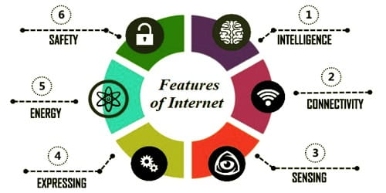

Figure 3. Features of IoT (meterial, 2022)

**Intelligence:** The exploit the knowledge from the data created is important. For example, a sensor generates the data, but that data will only be useful if it is interpreted properly. This identification is helpful in tracking the equipment and at times for querying its status.

**Connectivity:** Connectivity is an important characteristic or feature of IoT, if don't have communication seamless between related components of the IoT ecosystems, the IoT ecosystems may be broken. The IoT devices may be connected over Radio waves, Bluetooth, Wi-Fi, Li-Fi, etc. We can leverage various protocols of internet connectivity layers in order to maximize efficiency and establish generic connectivity across IoT ecosystems and Industries. There may be special cases where the IoT ecosystem is built on-premises or in an intranet.

**Sensing:** Maximum use of IoT devices, we need to read analog signals and convert them to suit each use case. We can use Electrochemical, gyroscopes, pressure, light sensors, GPS, Electrochemical, pressure, RFID, etc to gather data based on a particular issue. For example, for automotive use cases, we use Light detection sensors along with pressure, velocity, and imagery sensors.

**Expressing:** IoT is all about interacting intelligently with the outer environment and humans. Expressing enables this interactivity. Expressing allows us to show output into the real world and input from people and the environment.

**Energy:** From end components to connectivity and analytics layers, the whole ecosystems demand a lot of energy. While designing an IoT ecosystem, we need to consider design methodology such that energy consumption is minimal.

**Safety:** Safety is an important characteristic of IoT. In the whole flow of IoT ecosystems. The sensitive information is passed from endpoints to the analytics layer via connectivity components, so we need to adhere to proper safety, security measures, and firewalls to keep the data away from misuse and manipulations.

## 4. Applications of IoT

There are some applications of Internet of Things (IoT):

**Smart House:** A smart home refers to a convenient home setup where appliances and devices can be automatically controlled remotely from anywhere with an internet connection using a mobile or other networked device. Devices in a smart home are interconnected through the internet, allowing the user to control functions such as security access to the home, temperature, lighting, and a home theater remotely (HAYES, 2022)

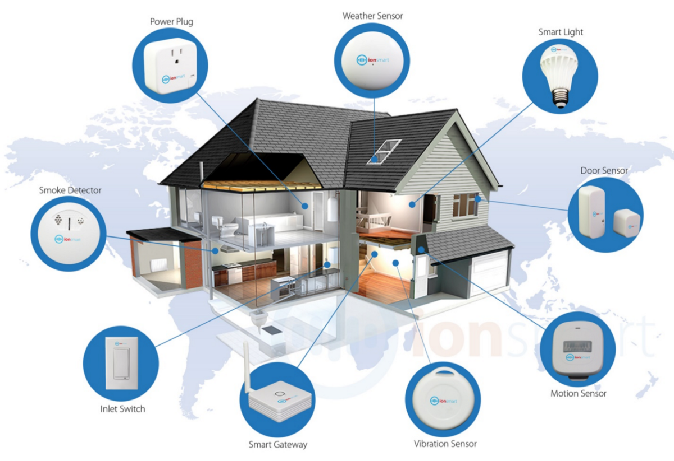

Figure 4. Application of IoT in Smart House (meterial, 2022)

**Wearables:** They are any device that you can attach to your clothes or wear as an accessory. They are a result of product development. Bluetooth headsets or Ipods were wearables; they were really popular nowadays. However, they evolved thanks to IoT. This technology gives them a new name, smart wearables, since now they collect information such as heart rate, burned calories, blood pressure, time spent exercising, and steps walked, among others (David, 2022)

Figure 5. Application of IoT in Wearables (meterial, 2022)

**Smart city:** The main goal of a smart city is to optimize city functions and promote economic growth while also improving the quality of life for citizens by using smart technologies and data analysis. A smart city is one that makes optimal use of all the interconnected information available today to better understand and control its operations and optimize the use of limited resources (twi-global, 2022)

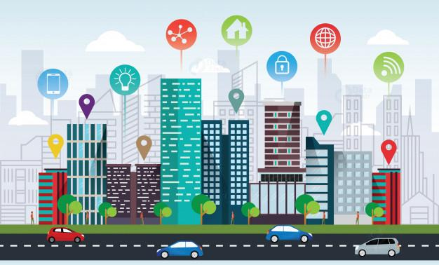

Figure 6. Application of IoT in Smart City (meterial, 2022)

**Smart grid:** In order to maintain a safe and secure electricity infrastructure that can accommodate future demand growth and to accomplish each of the following goals, which collectively define a Smart Grid increased use of digital information and control technologies to boost the electric grid's dependability, security, and effectiveness. dynamic resource and grid optimization with complete cyber security. integration and deployment of distributed generation and resources, including renewable sources. Deployment of "smart" technology for metering, communications about grid operations and status, and distribution (real-time, automated, interactive technologies that optimize the physical operation of appliances and consumer devices). deployment of "smart" technologies (real-time, automated, interactive technologies that enhance the functionality of consumer electronics and appliances) for metering, grid operations, status messaging, and distribution automation. combining consumer electronics with "smart" appliances. deployment and integration of cutting-edge peak-shaving and electricity storage technologies, such as thermal storage air conditioning and plug-in, and hybrid electric vehicles. providing customers with control alternatives and timely information creation of communication and interoperability standards for electrical equipment and appliances connected to the grid, as well as for the grid's supporting infrastructure Finding and removing unreasonable or unnecessary obstacles to the use of smart grid practices, technologies, and services (wikipedia, 2022)

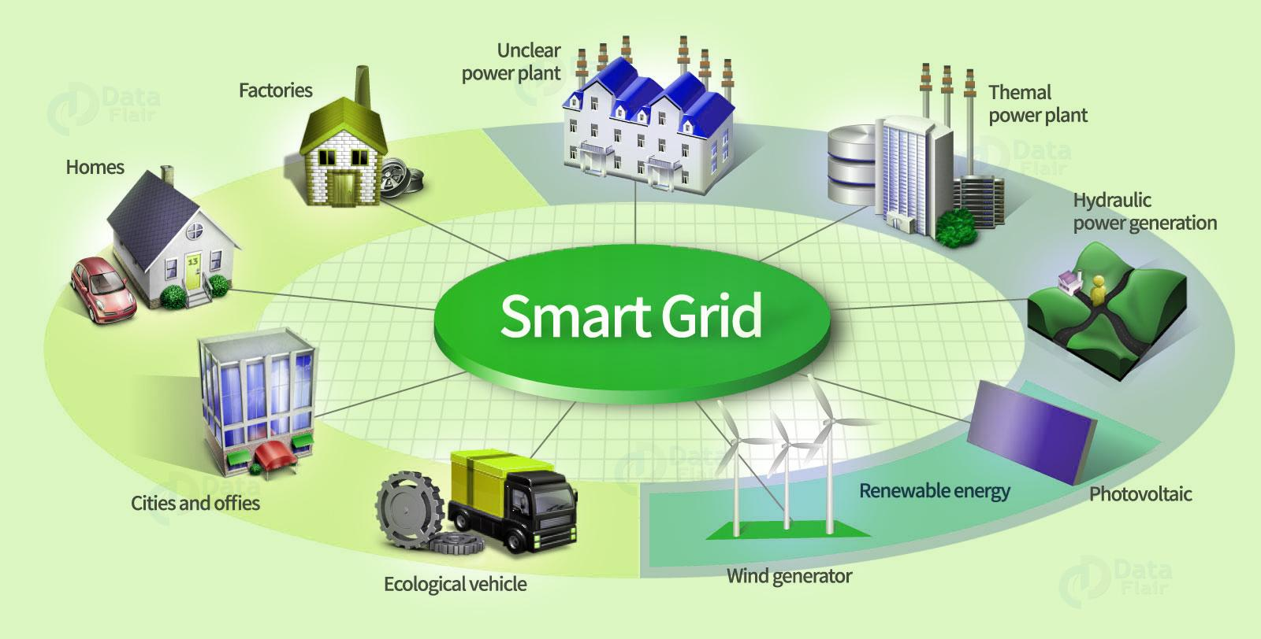

Figure 7. Application of IoT in Smart Grid (meterial, 2022)

## 5. Some examples for real world application of IoT

According to (azure.microsoft, 2022), there are some application of IoT in real world

**Remote monitoring:** Monitor almost any kind of asset—including heavy machinery, vehicles, and even livestock—almost anywhere, either continuously or at regular intervals. By tracking location, performance, condition, or environmental factors, the insights you gain from IoT-connected things may help you:

* Reduce your service costs and refine your business processes.
* Understand how your products are performing to provide a better experience for your customers.
* Increase the number of appointments per day, cut fuel costs, and reduce wear-and-tear by using machine learning capabilities to route freight or vehicles more efficiently.

Figure 8. Real world application of IoT in Remote monitoring (azure.microsoft, 2022)

**Predictive maintenance:** Similar to remote monitoring, predictive maintenance incorporates machine learning software that analyzes data to predict outcomes and automate actions. Predictive capabilities allow service providers to move beyond the traditional reactive and scheduled maintenance business model and use their data to identify issues before they become critical. This gives technicians the opportunity to intervene before customers even realize there's a problem. Armed with this information, you're able to:

* Figure out what mechanical or operational conditions are causing failures or slowdowns.
* Better predict what spare parts to keep in your inventory before repair issues arise.
* Move beyond a break/fix business model by preventing equipment failures through preventative maintenance.

Figure 9. Real world application of IoT in Predictive maintenance (azure.microsoft, 2022)

**Facilities management:** This IoT scenario is focused on monitoring your buildings, infrastructure, and other spaces, allowing you to improve energy efficiency, space utilization, productivity, and safety using the data you collect. The insights you gain may help you:

* Save money by automating lighting or optimizing heating and cooling cycles.
* Increase employee or occupant satisfaction by keeping equipment running or ensuring that supplies are stocked.

Figure 10. Real world application of IoT in Facilities management (azure.microsoft, 2022)

# II. Review standard and investigate architecture, frameworks, tools, hardware and APIs available for use in IoT development

## 1. Architecture of IoT

The architecture of the Internet of Things (IoT) includes some devices such as network structure and cloud services to allow IoT devices to communicate with each other. The architecture of IoT consists of some layers (celona, 2022)

**Sensors/Actuators:** Sensors or Actuators are the devices that are able to emit, accept and process data over the network. These sensors or actuators may be connected either through wired or wireless. This contains GPS, Electrochemical, Gyroscope, RFID, etc. Most of the sensors need connectivity through sensor gateways. The connection of sensors or actuators can be through a Local Area Network (LAN) or Personal Area Network.

**Gateways and Data Acquisition:** As large numbers of data are produced by these sensors and actuators need high-speed Gateways and Networks to transfer the data. This network can be of type Local Area Network (LAN such as WiFi, Ethernet, etc.), Wide Area Network (WAN such as GSM, 5G, etc.).

**Datacenter/ Cloud:** The Data Center or Cloud comes under the Management Services which process the information through analytics, management of devices, and security controls. Besides, these security controls and device management the cloud transfer the data to the end user's application such as Retail, Healthcare, Emergency, Environment, Energy, etc.

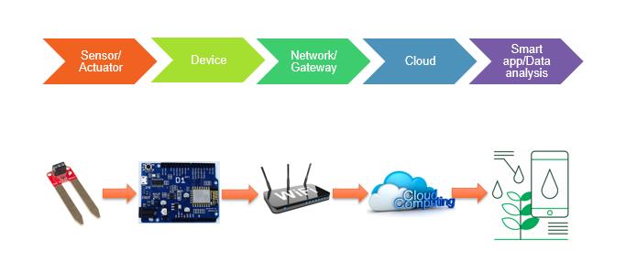

Figure 11. Architecture layers of IoT (meterial, 2022)

According to (geeksforgeeks, 2022), there is another architecture of IoT

**Sensing Layer:** Sensors, actuators, devices are present in this Sensing layer. These Sensors or Actuators accepts data and processes data and emits data over network.

**Network Layer:** The internet gateway, Data Acquisition System (DAS) are present in this layer. The DAS performs the data aggregation and conversion function (DAS collects the data and aggregation data, then DAS will convert the data of sensor to the digital data). Gateways which mainly opens up connection between sensor network and internet. Then, performing the basic function such as malware protection, and filtering and give decides based on the data

**Data processing Layer:** Here data is analyzed and handle before sending it to data center. The data is accessed from applications, this is the processing unit of IoT ecosystem.

**Application Layer:** This is the layer that data is handled and used by some end-user application such as agriculture, health care, aerospace, farming, defense, etc. Data will be handled at the data center or cloud

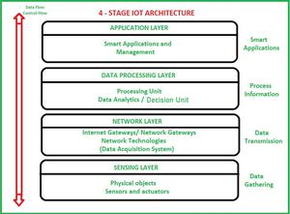

Figure 12. Architecture of IoT (geeksforgeeks, 2022)

According to (researchgate, 2022), here are the advantages and disadvantages of IoT architecture

|  |  |  |
| --- | --- | --- |
| **Architecture** | **Advantages** | **Disadvantages** |
| Cloud-Cloud or Cloud-Device | * Large computation power * Large Scalability | * Communication cost * Access to Internet * Security/Privacy issue |
| Devices | * Privacy ensured * No communication cost | * Small computation power * Low Scalability |
| Gate way | * Privacy ensured * No communication cost | * Medium computation power * Medium Scalability |

2. Framework of IoT

According to (meterial, 2022), there is the framework of IoT like this:

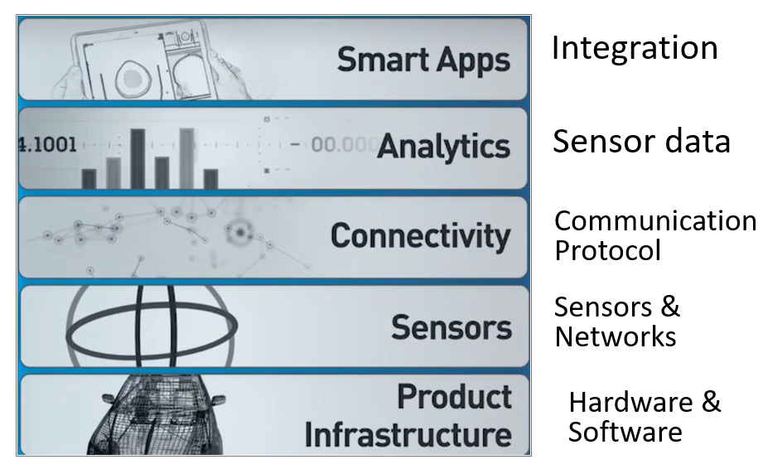

Figure 13. Framework of IoT (meterial, 2022)

* **Product Infrastructure layer:** Hardware & Software of the product
* **Sensor layer:** sensors & the networks that support them
* **Connectivity Layer:** Communication protocol necessary to send information from the product to the cloud
* **Analytics layer:** translating the sensor data into the meaningful information
* **Smart Apps layer:** integrates all of other layers together and support different business decisions.

**The ThingSpeak frameworks:**

* **ThingSpeak framework:** ThingSpeak is an IoT analysis platform that enables data streams to be aggregated, visualised and analysed, all in real time. In addition to the publicly accessible version on the web, ThingSpeak can also be hosted on your own server as an open-source application (zuehlke, 2014)

**Advantages of ThingSpeak:**

* ThingSpeak is a free IoT framework
* Easy to use
* ThingSpeak already offers good data visualisation capabilities for simple scenarios

**Disadvantages of ThingSpeak:**

* Channels themselves, with only eight data fields
* Very limited data processing and data forwarding options

## 3. Tools

According to (avsystem, 2019), there are some open-source tools for the Internet of Things (IoT):

**Arduino:** Arduino is an open-source user-friendly hardware and software prototyping platform. Dedicated for making small single-board computers able to sense and exercise control over the physical world. Arduino employs a set of hardware software specifications applied to interactive electronics which includes, among others, the Arduino programming language and the Integrated Development Environment (IDE).



Figure 14. Arduino Uno tool (avsystem, 2019)

According to (Sarwar, 2016), there is the following advantages and disadvantages of Arduino tool:

* **Advantages of Arduino tool:**
* **Ready to Use:** The biggest advantage of Arduino is its ready-to-use structure. As Arduino comes in a complete package form which includes the 5V regulator, a burner, an oscillator, a microcontroller, a serial communication interface, LED, and headers for the connections. Just plug it into the USB port of your computer and use it.
* **Effortless functions:** During the coding of Arduino, you will notice some functions which make the project so easy. Besides, Arduino has automatic unit conversion capability.
* **Large community:** There are many forums present on the internet in which people are talking about Arduino. Engineers, hobbyists, and professionals are making their projects through Arduino. We can easily find help with everything. Moreover, the Arduino website itself explains each and every function of Arduino.
* **Disadvantages of Arduino tool:**
* **Structure:** The structure of Arduino is its disadvantage as well. During building a project you have to make its size as small as possible.
* **Cost:** The most important factor which we cannot deny is cost. This is the problem that every hobbyist, Engineer, or Professional has to face.

**Node-RED:** Node-RED is a programming platform for intuitive and straightforward integration between various APIs, smart devices, and online services. To put it in other words, Node-RED is a flow-based development engine that groups together various visual flows using simple and intuitive editing services accessible from a web browser. Used to create JavaScript functions, it stores the created flows in the open-standard and widely used JSON file format which makes it possible to easily re-use or share them freely.

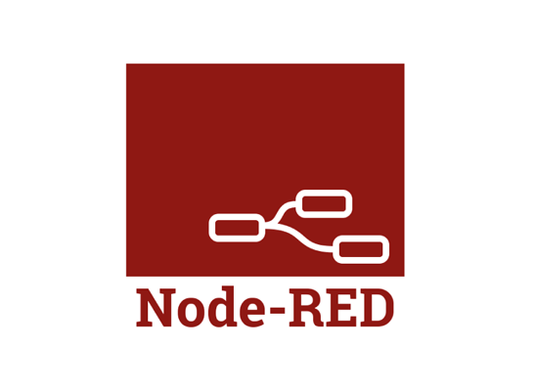

Figure 15. Node-Red tool (avsystem, 2019)

According to (subscription, 2022), here are the advantages of Node-RED tool

* **Advantages of Node-RED tool:**
* **Efficiency:** The FBP typified by Node-RED can be completed with almost only GUI operations. Node-RED flow editor takes care of building the application execution environment, library synchronization, the integrated development environment (IDE), and editor preparation so that you can concentrate on development.
* **High quality**: High quality is the true value of flow-based and visual programming. Each node provided as a component is a complete module that has been unit-tested. As a result, app authors can focus on checking the operation at the join level without worrying about the contents of the node. This is a big factor that eliminates human error at the single level and ensures high quality.
* **Open source:** Node-RED is an open-source piece of software. Therefore, it can be used flexibly under the Apache2 license.
* **Features of Node-RED tool:**

According to (Soppin, 2017), the major features of Node-RED are listed below:

* It supports browser-based flow editing.
* As it is built on Node.js, it supports a lightweight runtime environment along with the event-driven and non-blocking model.
* The various flows created in Node-RED are stored using JSON, which can be easily imported and exported for sharing with others.
* You can run it locally (Docker support, etc).
* It can easily fit on the most widely used devices like Raspberry Pi, BeagleBone Black, Arduino, Android-based devices, etc.
* It can run in a cloud environment like Bluemix, AWS, MS Azure, etc.

## 4. Hardware

According to (mindmajix, 2022), there is some type of hardware is used for the IoT system:

**Chips:** Microcontrollers, chips, integrated circuits, radio frequency systems, and other electrical and electronic devices are all included in this much broader classification.

**Sensors:** Power Management modules, Sensing modules, and Energy modules make up the three modules of sensors, which are one of an IoT system's foundational components.

**Actuators:** A data collection system that uses solenoids, comb drives, and other devices to gather information based on movements and receives motion from these devices.

**Common devices:** Standard gadgets comprise the for the most part utilized gadgets like Tablets, Cell phones, Switches, Switches, and so on. The settings that enable these devices to collect data are unique to each one.

According to (Prasanna, 2022), here are the advantages and disadvantages of IoT hardware

* **Advantages of hardware:**
* **Minimize human effort:** As IoT devices interact and communicate with each other, they can automate the tasks helping to improve the quality of a business’s services and reducing the need for human intervention.
* **Save time:** By reducing the human effort, it saves a lot of our time. Saving time is one of the primary advantages of using the IoT platform.
* **Enhanced data collection:** Information is easily accessible, even if we are far away from our actual location, and it is updated frequently in real-time. Hence these devices can access information from anywhere at any time on any device.
* **Improved security:** If we have an interconnected system, it can assist in the smarter control of homes and cities through mobile phones. It enhances security and offers personal protection.
* **Efficient resource utilization:** We can increase resource utilization and monitor natural resources by knowing the functionality and how each device works.
* **Reduced use of other electronic equipment:** Electric devices are directly connected and can communicate with a controller computer, such as a mobile phone, resulting in efficient electricity use. Hence, there will be no unnecessary use of electrical equipment.
* **Disadvantages of hardware:**
* **Security issues:** IoT systems are interconnected and communicate over networks. So, the system offers little control despite any security measures, and it can lead to various kinds of network attacks.
* **Privacy concern:** The IoT system provides critical personal data in full detail without the user’s active participation.
* **Increased unemployment:** Unskilled workers or even the skilled ones are at a high risk of losing their jobs, leading to high unemployment rates. Smart surveillance cameras, robots, smart ironing systems, smart washing machines, and other facilities are replacing the humans who would earlier do these works.
* **The complexity of the system:** The designing, developing, maintaining, and enabling the extensive technology to IoT system is quite complicated.
* **High chances of the entire system getting corrupted:** If there is a bug in the system, it is possible that every connected device will become corrupted.

Some common hardware:

**Arduino Uno:** An open-source development board for microcontrollers is known as an Arduino. The Arduino can be used to read sensors and control motors and lights (arduino, 2022)

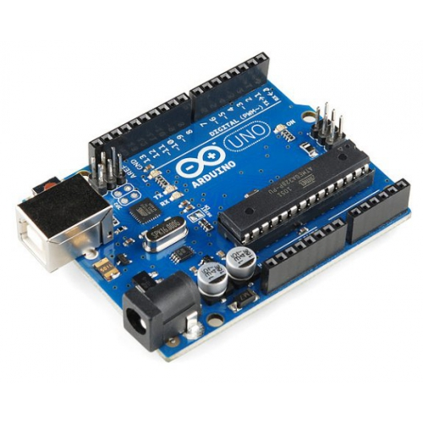

Figure 16. Arduino Uno hardware (arduino, 2022)

According to (Kashif, 2022), here are some advantages and disadvantages of Arduino Uno:

* **Advantages of Arduino Uno**
* **Easy to Use:** Arduino is super easy to learn. It uses a simplified version of C/C++ language which is easily adaptable. It is an ideal board for beginners. Arduino is a plug and play electronic board with a simple and minimalistic hardware interface.
* **Inexpensive Hardware:** Arduino boards are available at low cost. To start building our first program we just need an Arduino board as its development tool IDE is freely available. There is no need for any external hardware, multiple projects can be made using single Arduino boards which cut overall project cost by a great margin.
* **Active User Community:** Arduino is an open-source community with many online supports available on Arduino forum. Thanks to open-source nature of Arduino projects. Multiple Arduino projects starting from fan controllers to smart homes have been designed already.
* **Cross Platform Support:** Arduino is not only limited to Windows it is also available across multiple platforms like Linux and macOS.
* **Disadvantages of Arduino Uno:**
* **Lack of Multitasking:** Arduino boards are limited to run only a single program at a time.
* **Not Optimized for Performance:** Microcontrollers used in most Arduino boards are not ready to give their full performance.
* **Lack of Communications:** Arduino boards are limited in terms of Bluetooth and Wi-Fi support. Popular Arduino boards like UNO don’t have in-built communications support; we must interface external hardware modules to enable these functions.

**PIR Motion Thermal Sensor HC-SR501:** The PIR sensor stands for Passive Infrared sensor. It is a low-cost sensor that can detect the presence of Human beings or animals (components101, 2021)

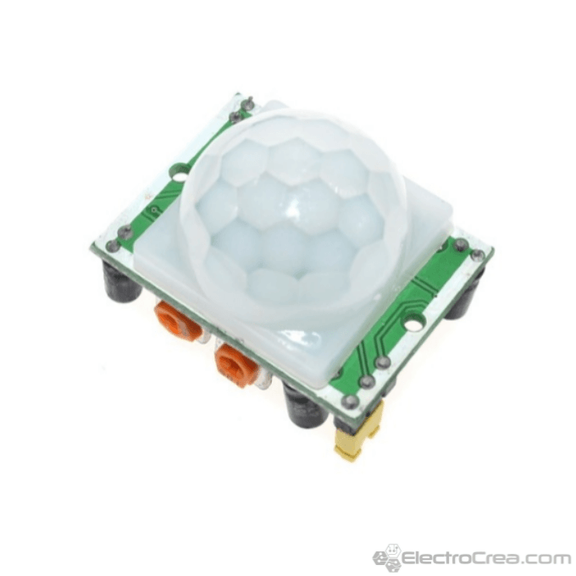

Figure 17. PIR Motion Thermal Sensor HC-SR501 hardware (electrocrea, 2022)

According to (hiktech, 2022), there are some advantages and disadvantages of PIR Motion Thermal Sensor:

* **Advantages of PIR Motion Thermal Sensor:**
* It can be used in very harse environment having irregular heat cycles (Active Motion Sensor).
* It has more lifespan which is about 100000 Hrs (Active type).
* It detects motion in light and dark conditions reliably in indoors. (Passive motion sensor)
* It helps in providing security by detecting suspicious movement.
* It is easy to install motion sensors.
* **Disadvantages of PIR Motion Thermal Sensor:**
* Radio frequency at high power is harmful for humans (active type).
* Radio frequency in microwave range do not penetrate metal objects (active type).
* Passive motion sensors do not operate above temperature of 350C.
* Passive sensor type works in LOS (Line of Sight) and does not work in non-LOS regions.
* Any kind of moving object can trigger the PIR sensor type.

## 5. API

According to (wallarm, 2022), API is the term referring to standard framework collection, protocols, and resources dictating the generic web and mobile application. It defines the communication rules that every application component must follow while exchanging information with each other. APIs that are used in the creation of IoT solutions are known as IoT APIs. They are the web services application programming interfaces. They work in a similar fashion and make seamless data flow, with HTTP being the medium. Using the IoT API lets developers design advanced applications that are easy to integrate with other web services. IoT APIs make the end-user experience exceptional in multiple manners. For instance, they can log in to the websites easily and bring a good number of applications on board.

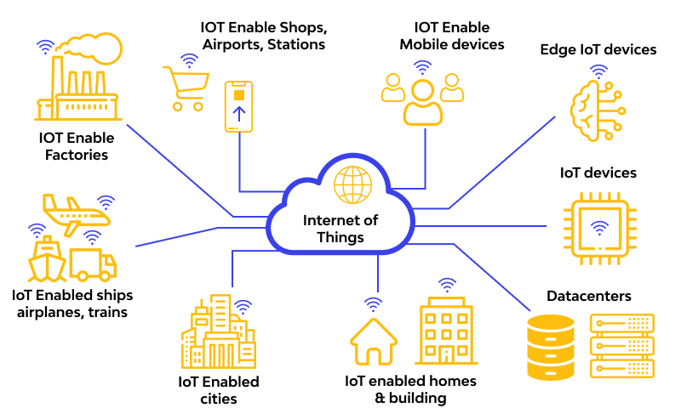

Figure 18. Apply API to IoT (wallarm, 2022)

Type of API:

**SOAP:** SOAP APIs are crucial for IoT device development as they make building a communication bridge between the servers and the clients. The API supports only XML-based data transfer.

According to (REYNOLDS, 2020), there are some advantages and disadvantages of Soap API

* **Advantages of Soap API:**
* **Highly secure:** SOAP APIs are used for enterprise-level web services that require enhanced security. Some of the most common APIs that use SOAP include those for payment gateways, financial services, CRM software.
* **Legacy system support**: SOAP is also highly preferred because of its support for legacy systems. Services that have been around for a while might have users that continue to utilize their services through the API. This ensures that users with legacy systems can continue to have access.
* **Supports stateful operations**: SOAP APIs are stateless by default but the great thing about SOAP is that it has support for stateful operations as well. This can be implemented with Web Services Specifications built on top of the XML standards. It's useful for scenarios where a chain of operations has to be made, such as bank transfers.
* **Built-in error handling:** Built-in error handling is a big advantage because if there's a problem with a request, the response will have the error information that can be used to fix the problem. This eliminates the guesswork from finding out exactly what went wrong.
* **Disadvantages of Soap API:**
* **Highly complex:** In comparison to Rest, SOAP is significantly more complex. It's also less flexible. This might present a challenge for developers that are not highly skilled. The extensive processing required may also slow down performance.
* **No variety of data formats:** SOAP is also extremely limited in its support of data formats. The formats supported by Rest include HTML, JSON, YAML, XML and others. Meanwhile, SOAP only supports XML.
* **API calls are not cached:** The process where a request is sent after an API is set up with the correct endpoints is referred to as an API call. The process results in the information being transferred, processed and feedback being provided. It's not possible for SOAP API calls to be cached.
* **Uses more bandwidth:** SOAP is generally slower in comparison to Rest and it also uses more bandwidth given its very complex nature. It’s another limiting factor in the efficacy of this technology for certain projects

**REST:** IoT REST APIs are useful for HTTP data transmission and for empowering IoT devices to stay associated with the rest of the world. These APIs are driven by architectural principles and boast features like interface simplicity, instant resource identification during the request, and manipulation of particular interfaces.

According to (REYNOLDS, 2020), there are some advantages and disadvantages of REST API

* Advantages of REST API
* **Greater flexibility:** This is perhaps one of the biggest advantages of a Rest API. The greater data flexibility is made possible because data is not tied to any resources or methods. Rest is thus able to work with different types of calls and return different data formats. It can even change structurally with accurate implementation of hypermedia.
* **Better scalability:** Many developers also choose to utilize the Rest API because of its scalability potential. This is made possible by the separation between the client and server. Rest operates on the concept that the client and server should be separate so that they can evolve on their own. This allows the development team to scale the product with relative ease.
* **Rest APIs are stateless:** Their stateless nature makes Rest APIs unique. Stateless in this respect means that none of the previous requests or responses are saved by the server. Every message is isolated so it's necessary for all of the data to be sent with the request. This makes every request more understandable and purposeful.
* **Uniform Interface:** This is another big advantage of the Rest API. Developers use the same standards and that means every API has the same uniform interface. The Rest API from one application can thus communicate in exactly the same manner with a completely different application, allowing for more efficient communication.
* Disadvantages of REST API:
* **Bound by constraints:** Rest APIs are by and large bound by six architectural constraints which include the uniform interface, the client-server based nature, stateless operations, layered system architecture, etc. It’s important to understand that these constraints exist before building out your API.
* **Learning curve for new developers**: It’s not exactly beginner friendly. Developers who aren't highly skilled might find themselves going through a steep learning curve when developing a Rest API. If they don't understand the limits of this web technology they could end up in situations where they get frustrated with its limitations.
* **Lacks security:** Unlike other Web APIs, Rest doesn't impose any security protocols. This means that it's not the ideal technology if the service requires confidential data to be passed between the client and server. On the other hand, it's better suited to publicly available services.
* **Limited transfer protocol support**: Other Web APIs like SOAP have support for a variety of different transfer protocols, including but not limited to HTTP, SMTP, UDP, and more. This puts Rest at a disadvantage since it only has support for the HTTP transfer protocol.

**JSON and XML:** A bit older than SOAP APIs, JSON and XML IoT APIs are based on a simple approach and consume limited bandwidth.

According to (Fang, 2021), here are the advantages and disadvantages of JSON and XML

* Advantages of JSON:
* Prebuilt serialization of objects hence less coding.
* Supports a wide variety of languages in parsing data.
* Easy to read and write.
* Easy access to data
* Allows easy use of arrays
* Disadvantages of JSON:
* No standardized schema limits
* Zero error handling for queries
* Supports only UTF-8 encoding
* Offers little security to data
* Advantages of XML:
* It is easy to maintain
* It has DTD and schema validation which reduce syntax errors.
* It contains self-documenting formats
* It supports a wide range of codes.
* Disadvantages of XML:
* Repetition of data
* Its storage is not cost-effective
* t is verbose hence has huge file sizes
* Slow parsing
* Complex algorithms that take time to learn

# III. Determine a specific problem to solve using IoT

## 1. Problem

When technology have not developed yet, we did not have a lot of technology applications with the devices in our homes to make them smart and we can control them flexibly and conveniently. With the Smart House project, I will perform some function such as auto turn on and off the light in house when have people, measure indoor temperature and humidity and the fan will auto turn on for air conditioning in house, and the people can control the light and fan in house from far away by application. For example, when you travel but you forgot turn off the fan or light in your house, now you can use control to turn of the fan or light from far away, this is convenient for you, but in the case, your house do not apply IoT, you will not turn off the fan or light when you forgot this will be terrible.

## 2. Solution

From the problem in part 1 of III, I will apply IoT to perform the Smart House and people can control devices in their house by application. I will perform the following features.

* Turning on and off the lights remotely via the web by accessing mobile phones or laptops.
* Turning on and off the fan or air conditioner remotely via the web by accessing a phone or laptop.
* It is the function of automatically turning on the fan or air conditioner when the indoor temperature rises, I will use the sensor to measure the indoor temperature and when the temperature rises, the fan will auto-turn on to reduce the temperatures in the house.
* It is the function of automatically turning off and on the lights when someone comes to the house, I will use the body temperature motion sensor and put it in front of the door and when someone comes to the house the sensor will receive the signal and will activate the trigger relay to turn on the light and the off light will automatically turn off when the sensor does not receive a signal of movement in front of the house.
* The last one, it's a rain sensor, this function will help me dry clothes easily and conveniently, I will use a rain sensor and servo for this function when it rains the drying pole will automatically turn into the roof to avoid rain and when it's sunny the drying pole will rotate outside the roof to dry clothes.

# References

amazon, 2022. *amazon.com.* [Online]   
Available at: https://aws.amazon.com/what-is/iot/  
[Accessed 24 11 2022].

arduino, 2022. *create.arduino.cc.* [Online]   
Available at: https://create.arduino.cc/projecthub/instar_aj/introduction-to-arduino-uno-the-easy-way-3de12f  
[Accessed 27 11 2022].

arrow, 2020. *arrow.com.* [Online]   
Available at: https://www.arrow.com/en/research-and-events/articles/understanding-the-importance-of-hardware-security  
[Accessed 26 11 2022].

Atoui, R., 2020. *iotforall.com.* [Online]   
Available at: https://www.iotforall.com/iot-security-common-criteria-framework  
[Accessed 26 11 2022].

avsystem, 2019. *avsystem.com.* [Online]   
Available at: https://www.avsystem.com/blog/10-open-source-iot-tools/  
[Accessed 25 11 2022].

azure.microsoft, 2022. *azure.microsoft.com.* [Online]   
Available at: https://azure.microsoft.com/en-us/resources/cloud-computing-dictionary/what-is-iot/#overview  
[Accessed 24 11 2022].

celona, 2022. *celona.io.* [Online]   
Available at: https://www.celona.io/network-architecture/iot-architecture  
[Accessed 25 11 2022].

components101, 2021. *components101.com.* [Online]   
Available at: https://components101.com/sensors/hc-sr501-pir-sensor

David, 2022. *deepseadev.com.* [Online]   
Available at: https://www.deepseadev.com/en/blog/wearables-and-iot/  
[Accessed 24 11 2022].

electrocrea, 2022. *electrocrea.com.* [Online]   
Available at: https://electrocrea.com/products/sensor-de-movimiento-pir-hc-sr501

Fang, A., 2021. *rapidapi.com.* [Online]   
Available at: https://rapidapi.com/blog/json-vs-xml-comparison/  
[Accessed 19 12 2022].

geeksforgeeks, 2022. *geeksforgeeks.org.* [Online]   
Available at: https://www.geeksforgeeks.org/architecture-of-internet-of-things-iot/  
[Accessed 25 11 2022].

HAYES, A., 2022. *investopedia.com.* [Online]   
Available at: https://www.investopedia.com/terms/s/smart-home.asp  
[Accessed 24 11 2022].

hiktech, 2022. *hiktech.com.* [Online]   
Available at: https://hiktech.com.my/5-advantages-disadvantages-of-motion-sensor/

Kashif, 2022. *linuxhint.com.* [Online]   
Available at: https://linuxhint.com/advantages-and-disadvantages-arduino/

meterial, G., 2022. *flm.greenwich.edu.vn.* [Online]   
Available at: https://flm.greenwich.edu.vn/gui/role/student/SyllabusDetails?sylID=2668  
[Accessed 25 11 2022].

microsoft, 2022. *microsoft.com.* [Online]   
Available at: https://learn.microsoft.com/en-us/azure/iot-fundamentals/iot-security-architecture  
[Accessed 26 11 2022].

mindmajix, 2022. *mindmajix.com.* [Online]   
Available at: https://mindmajix.com/iot-hardware-and-software#iot-hardware  
[Accessed 27 11 2022].

mulesoft, 2022. *mulesoft.* [Online]   
Available at: https://www.mulesoft.com/resources/api/top-3-benefits-of-rest-apis

Pedamkar, P., 2022. *educba.com.* [Online]   
Available at: https://www.educba.com/iot-features/  
[Accessed 24 11 2022].

Prasanna, 2022. *aplustopper.com.* [Online]   
Available at: https://www.aplustopper.com/advantages-and-disadvantages-of-iot/

researchgate, 2022. *researchgate.net.* [Online]   
Available at: https://www.researchgate.net/figure/Advantages-and-drawbacks-of-each-architecture_fig2_308848488

REYNOLDS, I. J., 2020. *zibtek.com.* [Online]   
Available at: https://www.zibtek.com/blog/rest-vs-soap/

Sarwar, I., 2016. *engineerexperiences.com.* [Online]   
Available at: https://engineerexperiences.com/advantages-and-disadvatages.html

Siagri, R., 2016. *linkedin.* [Online]   
Available at: https://www.linkedin.com/pulse/six-key-benefits-i-iot-architecture-roberto-siagri

Soppin, S., 2017. *opensourceforu.com.* [Online]   
Available at: https://www.opensourceforu.com/2017/09/node-red/

subscription, 2022. *subscription.packtpub.com.* [Online]   
Available at: https://subscription.packtpub.com/book/web-development/9781800201590/2/ch02lvl1sec05/node-red-benefits

Tabassi, A., 2022. *infotrust.* [Online]   
Available at: https://infotrust.com/articles/5-benefits-of-using-google-firebase/

thingspeak, 2022. *thingspeak.* [Online]   
Available at: https://thingspeak.com/pages/learn_more

twi-global, 2022. *twi-global.com.* [Online]   
Available at: https://www.twi-global.com/technical-knowledge/faqs/what-is-a-smart-city#SmartCityDefinition  
[Accessed 24 11 2022].

wallarm, 2022. *wallarm.com.* [Online]   
Available at: https://www.wallarm.com/what/api-management-for-iot  
[Accessed 26 11 2022].

wikipedia, 2022. *en.wikipedia.org.* [Online]   
Available at: https://en.wikipedia.org/wiki/Smart_grid#Definition_of_%22smart_grid%22  
[Accessed 24 11 2022].

zuehlke, 2014. *zuehlke.com.* [Online]   
Available at: https://www.zuehlke.com/en/insights/the-iot-platform-thingspeak-in-practical-test-0